**Introduction**

Building a calculator app is a common beginner's project in software development because it touches on many basic concepts while still being relatively straightforward. The requirements vary based on the platform (web, mobile, desktop) and the complexity (basic arithmetic vs. scientific calculations). Here's a general breakdown

**HTML**

<!DOCTYPE html>  
<html>  
<head>  
<title>Page Title</title>  
</head>  
<body>  
  
<h1>My First Heading</h1>  
<p>My first paragraph.</p>  
  
</body>  
</html>

* The <!DOCTYPE html> declaration defines that this document is an HTML5 document
* The <html> element is the root element of an HTML page
* The <head> element contains meta information about the HTML page
* The <title> element specifies a title for the HTML page (which is shown in the browser's title bar or in the page's tab)
* The <body> element defines the document's body, and is a container for all the visible contents, such as headings, paragraphs, images, hyperlinks, tables, lists, etc.
* The <h1> element defines a large heading
* The <p> element defines a paragraph

**What is an HTML Element?**

An HTML element is defined by a start tag, some content, and an end tag:

<tagname> Content goes here... </tagname>

The HTML element is everything from the start tag to the end tag:

<h1>My First Heading</h1>

<p>My first paragraph.</p>

|  |  |  |
| --- | --- | --- |
| **Start tag** | **Element content** | **End tag** |
| <h1> | My First Heading | </h1> |
| <p> | My first paragraph. | </p> |
| <br> | *none* | *none* |

**Note**: Some HTML elements have no content (like the <br> element). These elements are called empty elements. Empty elements do not have an end tag!

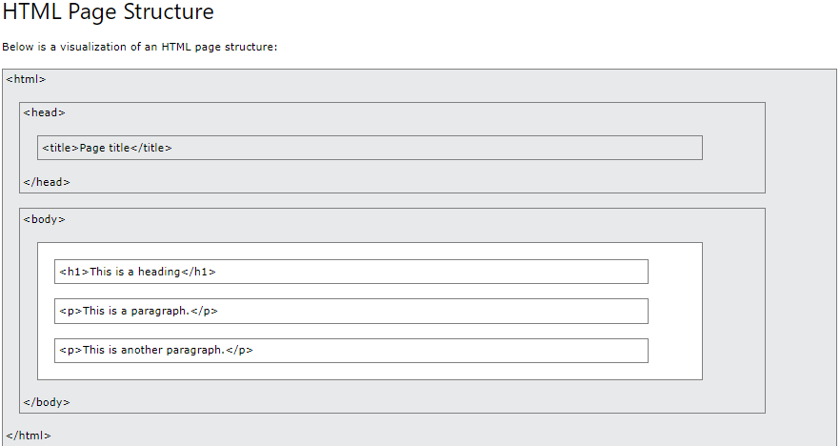

**HTML Attributes**

An HTML element is defined by a start tag, some content, and an end tag.

HTML attributes provide additional information about HTML elements.

All HTML elements can have attributes

* Attributes provide additional information about elements
* Attributes are always specified in the start tag
* Attributes usually come in name/value pairs like: name="value"